Hadoop Developer – Flume Lab Exercises
Hadoop Developer Training-
Flume Lab Book

Table of Contents

- Importing Twitter data into HDFS ……………………………………… 3

- Login to https://twitter.com/

- After successful login go to https://apps.twitter.com

- Click on Create New App

- Fill in mandatory fields and click on create your Twitter application.

- Application will be created, Click on Keys and Access Token
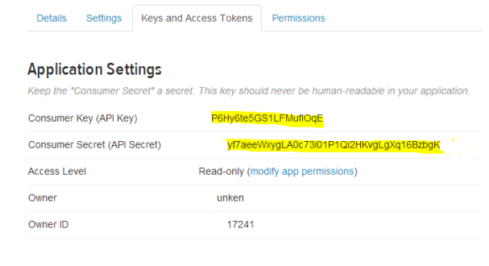
- Create Access Token by clicking “Create my access token”

- Edit flume.conf file:
Command: vi /usr/lib/flume-ng/apache-flume-1.4.0-bin/conf/flume.conf

- Replace all the below highlighted credentials in flume.conf with the credentials (Consumer Key, Consumer Secret, Access Token, Access Token Secret) received after creating the application very carefully, rest all will remain same, save the file and close it

Note: The credentials shown in the screenshots are just sample ones, create your own credentials and use.

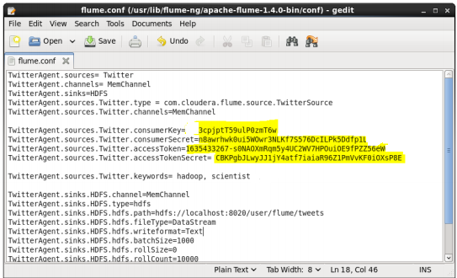

- Use the command to fetch data from Twitter:
Command: ./flume-ng agent -n TwitterAgent -c conf -f /usr/lib/flume-ng/apache-flume-1.4.0- bin/conf/flume.conf


About Capgemini
With almost 145,000 people in over 40 countries, Capgemini is one of the world's foremost providers of consulting, technology and outsourcing services. The Group reported 2014 global revenues of EUR 10.573 billion.
Together with its clients, Capgemini creates and delivers business and technology solutions that fit their needs and drive the results they want. A deeply multicultural organization, Capgemini has developed its own way of working, the Collaborative Business Experience™, and draws on Rightshore®, its worldwide delivery model

 | Name Name  Function  Function  Phone:00 00 00 00 00  email@capgemini.com
Name Name
Function
Function
Phone:00 00 00 00 00
email@capgemini.com
Name Name
Function
Function
Phone:00 00 00 00 00
email@capgemini.com
Name Name
Function
Function
Phone:00 00 00 00 00
email@capgemini.com
www.capgemini.com

The information contained in this document is proprietary and confidential.
It is for Capgemini internal use only. Copyright © 2015 Capgemini. All rights reserved.
Rightshore® is a trademark belonging to Capgemini.

